Coordinating Conjunctions

🔹 What Are Coordinating Conjunctions?
# Source: AI Source: Provided by: [Data Path: Persons Table -> ID Column: 1, Name_En Column: Motasem Essam] -> From: [Chatgpt (GPT-4-turbo)] on [7/28/2025]
Coordinating conjunctions are used to connect words, phrases, or independent clauses that are grammatically equal or similar in structure.

✅ Key Features
# Source: AI Source: Provided by: [Data Path: Persons Table -> ID Column: 1, Name_En Column: Motasem Essam] -> From: [Chatgpt (GPT-4-turbo)] on [7/28/2025]
- They join elements of equal importance
- Often used to link two sentences or parts of a sentence
- Commonly remembered with the acronym FANBOYS

🧩 FANBOYS – The 7 Coordinating Conjunctions
# Source: AI Source: Provided by: [Data Path: Persons Table -> ID Column: 1, Name_En Column: Motasem Essam] -> From: [Chatgpt (GPT-4-turbo)] on [7/28/2025]
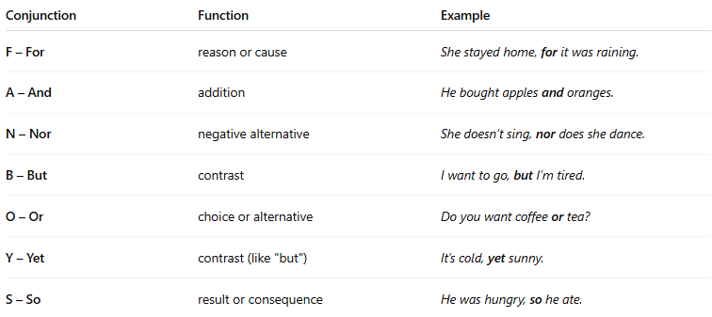
Conjunction | Function | Example
F – For | reason or cause | She stayed home, for it was raining.
A – And | addition | He bought apples and oranges.
N – Nor | negative alternative | She doesn’t sing, nor does she dance.
B – But | contrast | I want to go, but I’m tired.
O – Or | choice or alternative | Do you want coffee or tea?
Y – Yet | contrast (like "but") | It’s cold, yet sunny.
S – So | result or consequence | He was hungry, so he ate.

🔹 Examples in Sentences
# Source: AI Source: Provided by: [Data Path: Persons Table -> ID Column: 1, Name_En Column: Motasem Essam] -> From: [Chatgpt (GPT-4-turbo)] on [7/28/2025]
- And: I cleaned the room and did the laundry.
- But: He tried hard, but he failed.
- Or: You can choose this or that.
- So: I was late, so I took a taxi.

🧠 Tip
# Source: AI Source: Provided by: [Data Path: Persons Table -> ID Column: 1, Name_En Column: Motasem Essam] -> From: [Chatgpt (GPT-4-turbo)] on [7/28/2025]
When joining independent clauses, use a comma before the coordinating conjunction:
✅ I was tired, so I went to bed.

